To get the initalise and to check status:
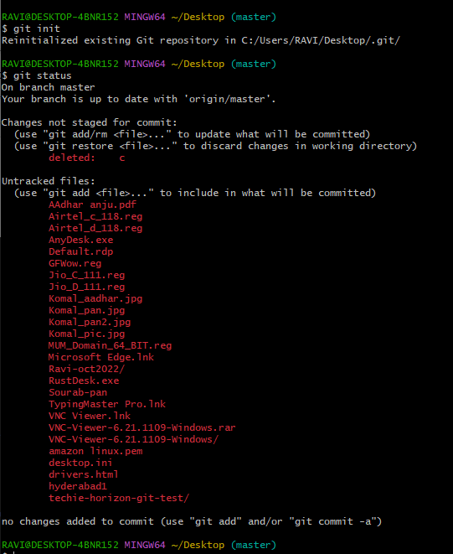

To get the list of configuration: 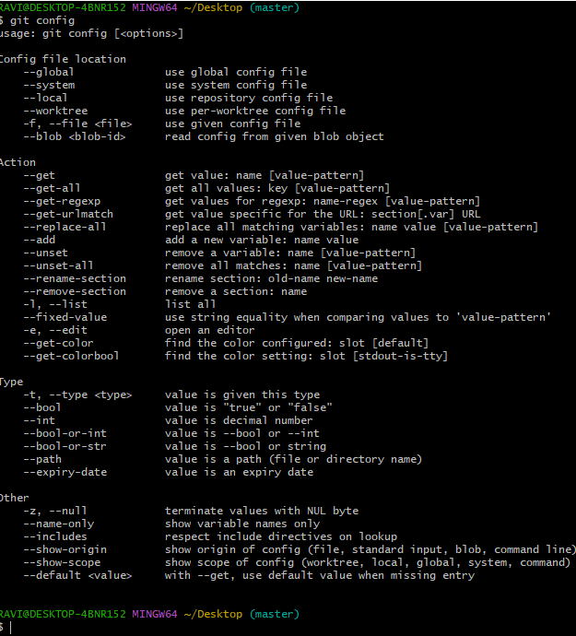

To add user.name:
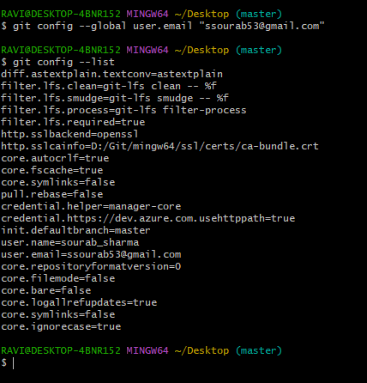
Created multiple files:
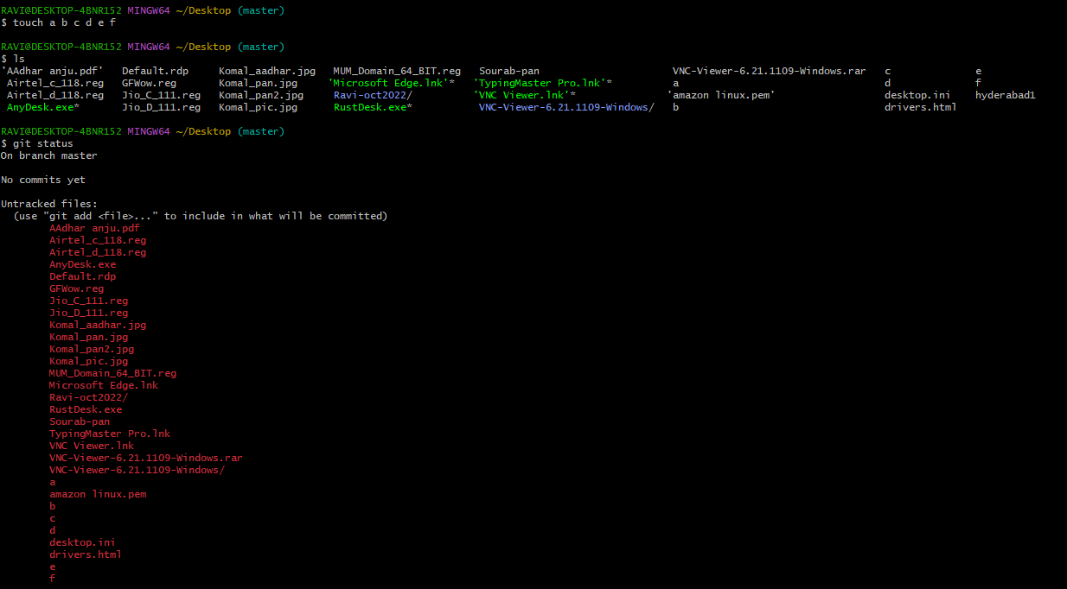
Added multiple files to tracking area:
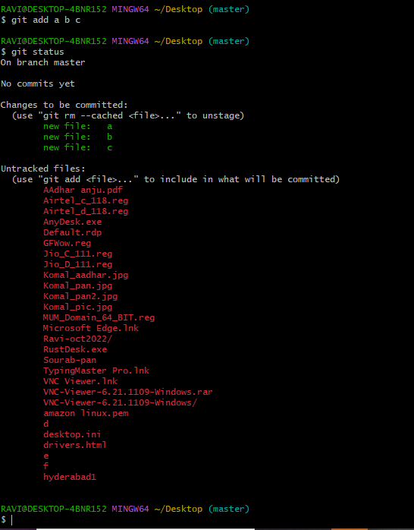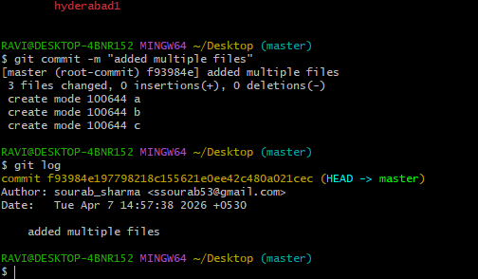

Created a new repository and generated the passkey for it:
https://github.com/Shaso6x/techie-horizon-git-test.git
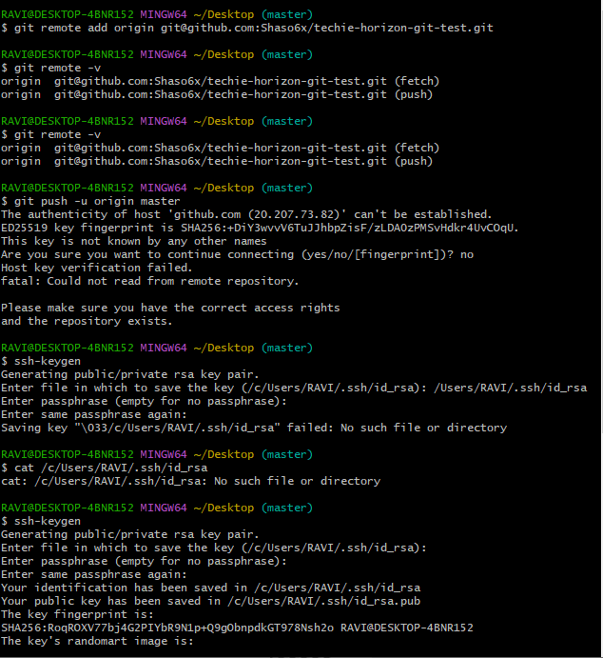

Pushed a file to new repository:
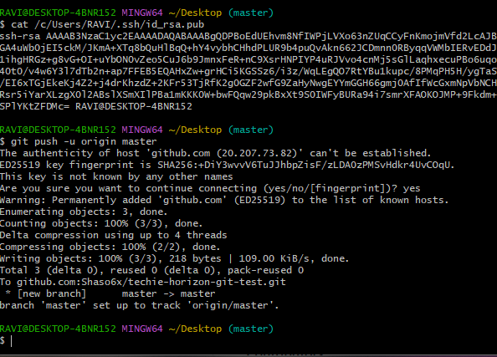
URL for the newly created repository:
git@github.com:Shaso6x/techie-horizon-git-test.git
Deleted the files as shown:
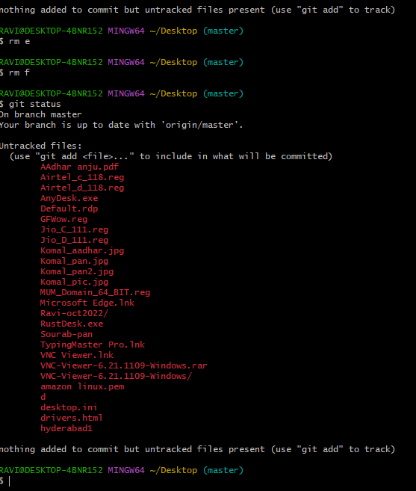
Created a new file and updated the same in respository:
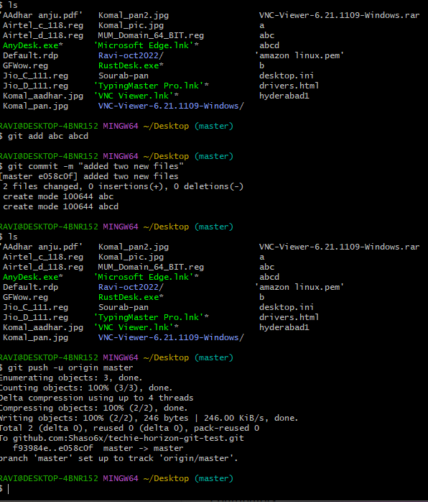
Git clone:
